**Implementing the Blue Economy: Analysis of indicator interrelationships across countries and over time**

Table 1S: Data sources to get the variables used in the paper.

|  |  |
| --- | --- |
| Variable name | Source |
| Air transport | <https://data.worldbank.org/indicator/IS.AIR.DPRT> |
| Biodiversity - Habitat | <https://oceanhealthindex.org/global-scores/data-download/> |
| Biodiversity - Species | <https://oceanhealthindex.org/global-scores/data-download/> |
| Business environment | <https://tcdata360-backend.worldbank.org/api/v1/datasets/744/dump.csv> |
| Clean waters | <http://www.oceanhealthindex.org/methodology/goals/clean-waters> |
| Control of corruption | <https://info.worldbank.org/governance/wgi> |
| Economic inequality | <https://fragilestatesindex.org/indicators/e2/> |
| Factionalized elites | <https://fragilestatesindex.org/indicators/c2/> |
| Gender inequality index | <https://hdr.undp.org/sites/default/files/2021-22_HDR/HDR21-22_Statistical_Annex_GII_Table.xlsx> |
| Government effectiveness | <http://info.worldbank.org/governance/wgi/Home/downLoadFile?fileName=wgidataset.xlsx> |
| Group grievance | <http://fundforpeace.org/fsi/indicators/c3/> |
| Human flight and brain drain | <https://fragilestatesindex.org/indicators/e3/> |
| Human rights and rule of law | <http://fundforpeace.org/fsi/indicators/p3/> |
| Investor protection index | <https://govdata360.worldbank.org/indicators/h0f6d6fc5?country=BRA&indicator=647&viz=line_chart&years=2007,2017> |
| Port infrastructure | <https://databank.worldbank.org/metadataglossary/world-development-indicators/series/IQ.WEF.PORT.XQ> |
| Public services | <https://fragilestatesindex.org/indicators/p2/> |
| Regulatory quality | <http://info.worldbank.org/governance/wgi/> |
| Secure internet servers | <https://data.worldbank.org/indicator/it.net.secr.p6> |
| Shipping connectivity | <https://unctadstat.unctad.org/wds/TableViewer/tableView.aspx?ReportId=92> |
| State legitimacy | <https://fragilestatesindex.org/indicators/p1/> |
| State of the economy | <https://fragilestatesindex.org/indicators/e1/> |

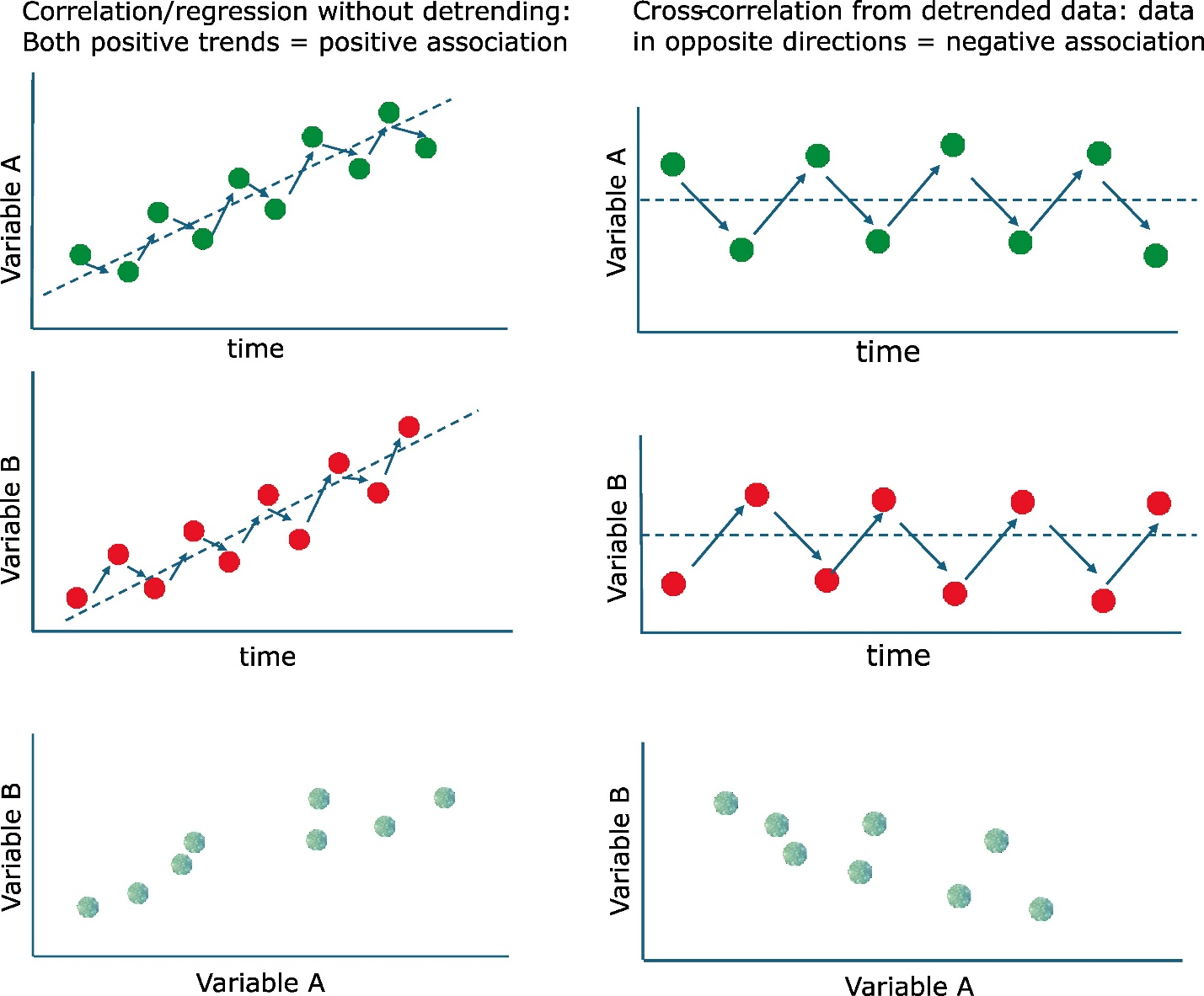

Figure S1. Theoretical comparison of time series with and without detrend